Programming IDE: Android Studio or Kotlin Playground

- Write a Kotlin program that generates the first N numbers in the Fibonacci sequence. Use the following code template. You need to implement the generateFibonacci() function that should return a list of the first N Fibonacci numbers (8pts).

val count = 10 // Change this to the number of Fibonacci numbers you want to generate
val fibonacciNumbers = generateFibonacci(count)
Log.d("Midterm", "First $count Fibonacci numbers: $fibonacciNumbers")

// ... implement here!

Output examples)

* Submit your kt file (for Android Studio) or txt file (for Kotlin playground)
to eClass – Assignment – MP1

* The Fibonacci sequence is a series of numbers in which each number is the sum of the two preceding numbers, starting with 0 and 1.

- Write a Kotlin program that finds the most frequently occurring word in a given string (case-insensitive). If there are multiple words with the same highest frequency, print the first one that appears. Use the following code template (10pts).

// Define the string directly in the code for testing
val input = "the quick brown fox jumps over the lazy dog the fox"

… implement here!

Output examples)
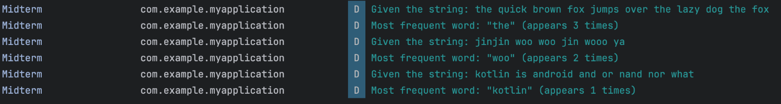

* Submit your kt file (for Android Studio) or txt file (for Kotlin playground)
to eClass – Assignment – MP2

- Randomly pick the number of rows and columns (between 2 and 5, respectively), generate a 2D matrix with random numbers between 10 and 99, and print it. After that, calculate and print (19pts):
- The sum of all elements in the matrix
- The average of all elements (rounded to 2 decimal places)
- The index of the column with the highest sum
- In case multiple columns have the same highest sum, print the index of the first one.

Output examples)

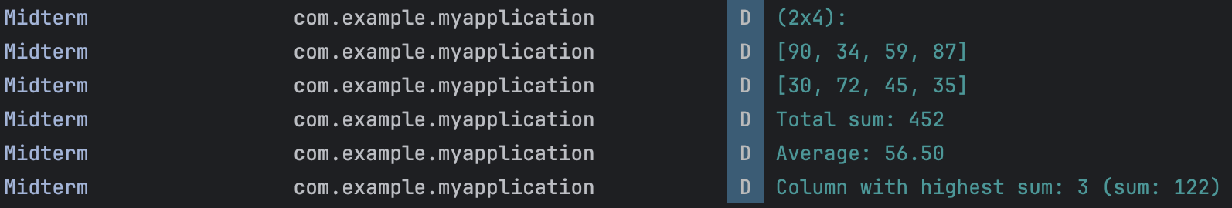

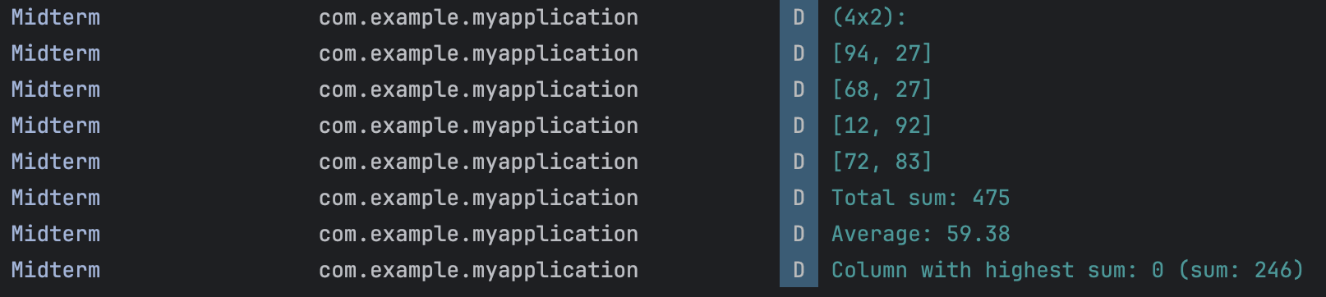

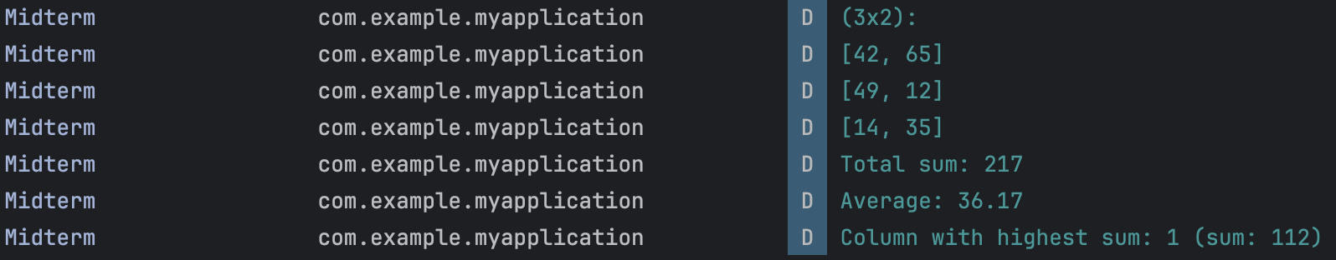

* Submit your kt file (for Android Studio) or txt file (for Kotlin playground)
to eClass – Assignment – MP3

